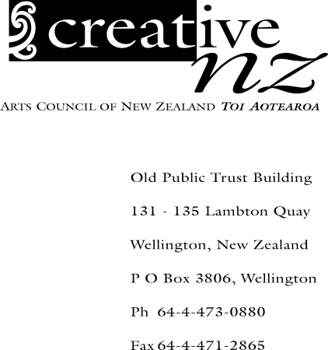Media release

To: Literary Editors/Arts Editors/Chief Reporters
Date: 26 November 2002

No of pages: 2

Increased resources for
New Zealand literary sector

More than half of the Government’s additional funding of $1 million (inc. GST) per year to the literary sector, announced in May this year, will supplement the New Zealand Authors’ Fund and result in increased payments to most authors registered with the Fund when the annual payment is made in mid-December.

The New Zealand Authors’ Fund, administered by Creative New Zealand, compensates New Zealand writers for the loss of income through royalties when their books are borrowed from public libraries. The additional funding will take this year’s total payment to 1371 writers to $1.5 million (exc. GST), an increase of $500,000 on the previous year’s payment.

Following the Government’s announcement of increased funding to the literary sector, representatives from Creative New Zealand and the Ministry for Culture and Heritage met with a writers’ consultative group to draw up recommendations on the best use of the funds.

As a result, Creative New Zealand’s funding to the literary sector will be significantly enhanced. The remaining funding will be used to establish three Prime Minister’s Literary Awards, each worth $60,000 and awarded annually in the categories of fiction (including scriptwriting), non-fiction and poetry. A multi-year fellowship, available annually and valued at $100,000, will also be established.

Creative New Zealand will administer these awards and the fellowship. It will also work with the Ministry for Culture and Heritage to develop and implement an ongoing audience development initiative for New Zealand authors and literature.

Prime Minister Helen Clark said New Zealand authors had long played an important role in expressing and projecting what was unique about this country.

“We are delighted that the additional government funding will broaden the range of opportunities offered to New Zealand writers as well as significantly increase the resources available to the Authors’ Fund,” she said.

Peter Biggs, Chair of Creative New Zealand, welcomed the Government’s commitment to supporting the literary sector.

“What writers most need is a sustained period of time to research and write new work. That’s what these awards and the fellowship will provide,” Mr Biggs said. “I look forward to reading the results of this additional funding in the years ahead.”

Speaking for the New Zealand Society of Authors, Executive Director Liz Allen said additional funding recognised the need for extra support so that writers could continue to build a strong literary heritage.

“The money set aside for audience and market development will be a valuable contribution to creating a more viable industry for both writers and publishers in New Zealand,” she said.

Michael King, award-winning non-fiction writer and a member of the writers’ consultative group, applauded the additional government funding to literature.

“The establishment of a multi-year fellowship is especially good news for biographers and historians,” he said. “It raises for the first time the possibility that major books of this kind can be funded from a single source. Some books that previously could not have been completed without strong funding support will now be written.

“It also means that such books will have the coherence that only continuity of funding and sustained writing over several years can provide.”

ENDS

Undine Marshfield
Media and Communications Adviser
04-498 0725
025 965 925
undinem@creativenz.govt.nz

